NextGen Paediatric Innovation and Impact Challenge (NPIIC) 2026
Guidance and Application Form
New Application deadline: Friday 30 October 2026, 5 p.m.
Aim
The challenge aims to bring together clinical and non-clinical early career researchers (ECRs) to co-develop bold, cross-disciplinary translational innovative concepts with clear potential to improve outcomes in children with rare and/or complex conditions. A total funding pot of £30,000 is available through this challenge and will be awarded across the top three (3) winners.
What we are looking for:
Early-stage paediatric innovation led by ECRs, with a focus on translating ideas into fundable concepts. We are particularly keen to support ideas that could lead to collaboration with industry or may present opportunities for commercial impact.
You could use the award to:
- De-risk high-potential ideas at concept stage
- Build interdisciplinary teams.
- Create a pipeline for future funding opportunities through NIHR programme (including i4i and RfPB), charities, or industry funding.
Webinars
The GOSH BRC team will be holding two webinars on August 12th and August 26th to support your application. The sessions will include a brief overview of the challenge, guidance on eligibility and application requirements, and examples of innovative ideas from representatives from the NIHR Research for Patient Benefit (RfPB) programme. We encourage all applicants to attend, at least, one of the webinars. Zoom details can be found below. A recording of the Webinars can be found on YouTube - https://youtu.be/T5f1twOO-X8?si=Cv1inT-Sq5GnpTfr

Webinar 1: Innovative Project Eligibility and Guidance  Date: August 12th, 2026  Time: 13:00 – 14:00  Join Zoom Meeting  https://us02web.zoom.us/j/82899801463?pwd=EtbzljCsegzb7q17boyG9INwobehyO.1  Meeting chat link  https://us02web.zoom.us/launch/jc/82899801463  Meeting ID: 828 9980 1463  Passcode: 392723 | Webinar 2: Innovative Project Eligibility and Guidance  Date: August 26th, 2026  Time: 13:00 – 14:00  Join Zoom Meeting  https://us02web.zoom.us/j/86842243644?pwd=JWSdv33NbmpcWy3v8xGmnMIW29ffWI.1  Meeting chat link  https://us02web.zoom.us/launch/jc/86842243644  Meeting ID: 868 4224 3644  Passcode: 856362

Background
The National Institute for Health and Care Research (NIHR) has funded a Biomedical Research Centre (BRC) at Great Ormond Street Hospital (GOSH), alongside our academic partner UCL Great Ormond Street Institute of Child Health (UCL GOS ICH) since 2007. The centre provides cutting-edge facilities and world leading expertise and access to over 200 rare disease patient populations. This enables our staff and NHS, university, and industry collaborators to conduct pioneering translational research into childhood illnesses.
Now in its fourth term of funding, the NIHR GOSH BRC has five research themes: genomic medicine; tissue engineering; gene, stem, and cellular therapies; accelerating novel therapies; and applied child health and informatics. Alongside these themes, our Central Development Hub supports our Career Development Academy, Business Development, Patient and Public Involvement and Engagement (PPIE), and Equity, Diversity, and Inclusion (EDI) activities, all of which contribute to our ongoing efforts to translate research into patient benefit. In September 2026, we will submit a bid to continue our BRC from 2028. This will build on the legacy of BRC4 but will be re-organized into a new thematic structure.
Central to delivering the BRC’s strategy is our Paediatric Excellence Initiative, a partnership between the BRC, Alder Hey Children’s Hospital, Birmingham Women’s and Children’s Hospital and Sheffield Children’s Hospitals. The initiative enables the spread of scientific excellence within paediatric translational research ensuring more children will benefit from translating the most promising health and clinical technologies.
Challenge Format
Applicants will progress through a structured three-stage process. A three-month open call launches in July 2026 and closes October 2026. Teams must submit a completed application form (see form below) by 5pm on 30 October 2026. Applications will be reviewed and short-listed by a panel representing all five BRC themes, patient, and public representatives. We will assess innovativeness, translational potential, collaboration strength, feasibility, and alignment with the priority areas.
Shortlisted teams will advance to the live NPIIC (Dragons’ Den style) event in December 2026, where they will deliver a five-minute pitch followed by panel Q&A. The panel will include BRC theme leads, senior investigators, industry partners, and patient/public representatives.
The competition centres on generating high-quality innovative ideas aligned with the priority areas highlighted below. Each submission requires at least one clinical and one non-clinical co-applicants; both should be ECR (see definition of ECR in the eligibility criteria section below). We are keen to see submissions that strengthens cross-theme and cross-institute collaboration and encourage solutions that combine scientific creativity with clinical relevance.
Scope and Themes
Innovative projects must align with at least one of the following priority areas. Applicants are expected to have generated experimental or have secondary data to support the case for further development and illustrate technical feasibility.

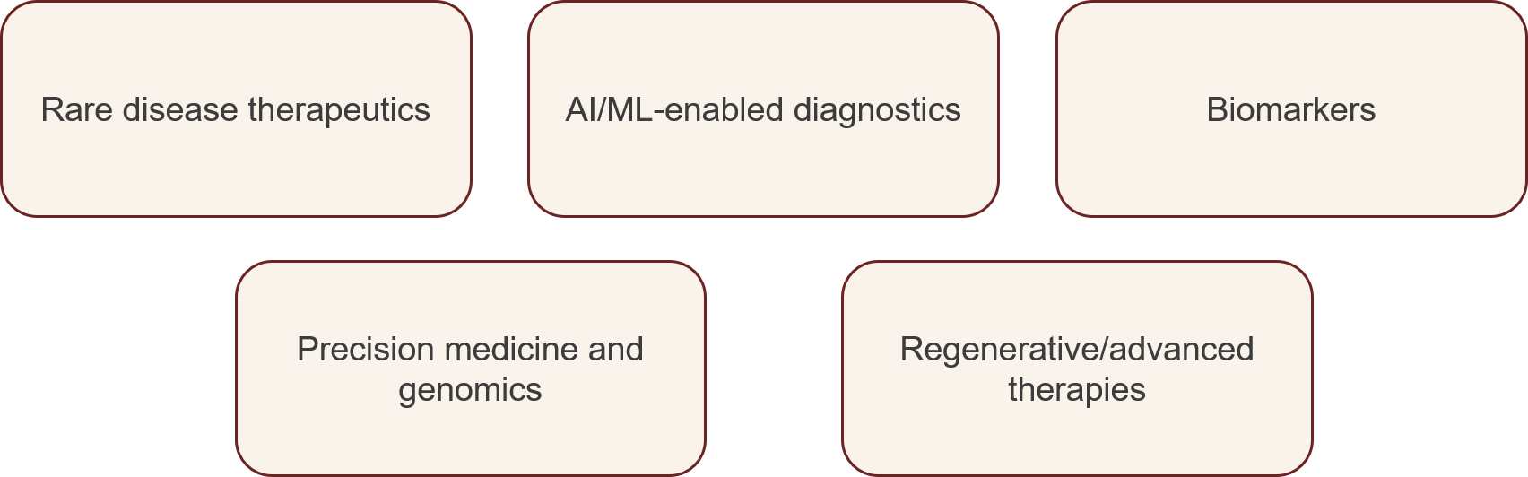
Eligibility
Each team must include at least one clinical and non-clinical ECR* with a substantive^ employment with GOSH, UCL GOS ICH or the Paediatric Excellence Initiative Partner (i.e. Alder Hey, Birmingham and Sheffield). Researchers from all professional backgrounds are welcome to apply, including non-clinical staff, clinicians, nurses, allied health professionals (AHPs), pharmacists, health care scientist staff, and any others not mentioned here. Multidisciplinary collaboration is strongly encouraged.
*For the purposes of this call, an early career researcher is defined as someone who:
- Holds a PhD (or equivalent)
- Has received no more than £250,000 in total grant income as Primary Investigator across their career (excluding their own salary e.g. a fellowship grant), and
- Does not hold a tenured academic position.
^If your employment contract is due to end before November 2027, please contact the BRC (brc@gosh.nhs.uk) to discuss your eligibility for this challenge. Applications from individuals in this situation will be considered on a case-by-case basis.
Funding Model
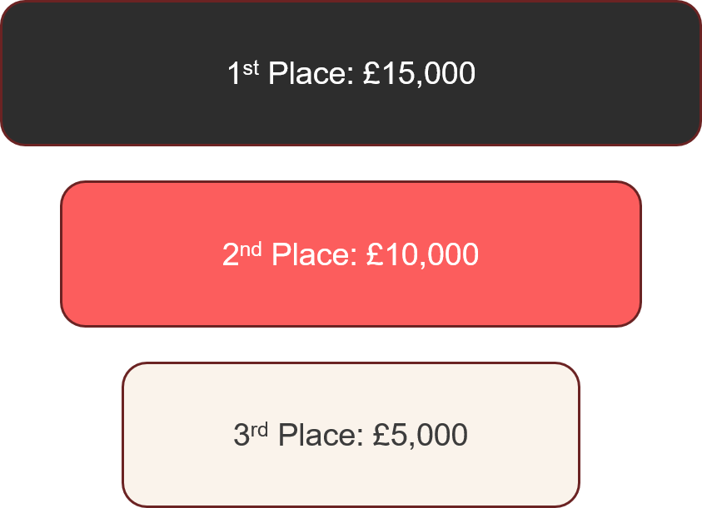
Applicants will compete for a total prize fund of £30,000 with awards of £15,000, £10,000, and £5,000 for the top three winners. In addition, winners will be offered grant-development support to strengthen future funding bids (e.g., NIHR, MRC, or charitable sources).
Funds will be awarded in December 2026. NPIIC 2026 winners will be expected to participate in a NPIIC Showcase event to be held in November 2027, where they will present the progress of their projects. See the expected outcomes section below.
Assessment Criteria
We expect that teams applying for the NPIIC 2026 to demonstrate that their innovative idea is credible, needed, feasible and worth investing in early. Applications will be reviewed on unmet need and patient/public impact, innovation and novelty, early-stage feasibility, translational potential, team strength and interdisciplinarity, future funding and commercialization potential. Therefore, teams must demonstrate:
a) A specific paediatric problem with evidence that it is clinically important and currently underserved
b) A novel, credible idea (what the innovation is, what makes it new or different, and why it is better than existing approaches)
c) Early feasibility thinking (preliminary data, strong rationale, or supporting literature)
d) A practical, deliverable plan (what the NPIIC funding will be used for, including defined outputs e.g. (data, prototype, model etc.)
e) Translational Intent (further funding for idea development e.g. NIHR i4i PDA, MRC DPFS etc.)

Conditions of Award

- Winners must commit to presenting a progress of their innovation project at the November 2027 NPIIC Showcase.
- Winners must acknowledge the NIHR GOSH BRC in all publications and presentations and provide progress reports upon request, including one year after the award end date.

Expected Outputs of NPIIC 2026 Winners
a) Winners should generate tangible evidence demonstrating that their proposed innovation is feasible and has potential for further development (e.g. feasibility data, early prototype or mock-ups, pilot datasets, or demonstrations of technical feasibility)
b) Winners are expected to show defined next development steps, regulatory considerations (where relevant), and clinical integration pathways at the end of the award period.
c) Winners are expected to submit a competitive follow-on grant such as NIHR RfPB, NIHR i4i PDA, Charity funding, MRC DPFS etc

Application and Selection Process

- The deadline for application submission is 30th October2026, 5 p.m.
- A Review panel will assess and shortlist applications. The shortlisting panel will include the BRC themes representatives, BRC Junior Faculty leadership and patient and public representatives.
- Shortlisted teams will advance to the live Dragons’ Den event in December 2026, where they will deliver a five-minute pitch followed by panel Q&A. The judging panel will include theme leads, senior investigators, industry partners, and patient/public representatives.
- To apply, please complete the application form below and submit an electronic copy (in Word format) to brc@gosh.nhs.uk.

Selection Criteria

- Innovation and scientific excellence of the proposed project.
- Translational potential – the likelihood that the project outcomes will support further research or strategic activity within the relevant research theme, leading to patient and/or economic benefit.
- Potential for future translational impact – this may include, but is not limited to, patient benefit through novel interventions or biomarkers, changes to clinical guidelines or practice, future external funding, and/or patent filing or commercial activity.
- Feasibility and deliverability – based on the resources available/requested, proposed timelines, and the expertise of the applicant(s).
Please contact brc@gosh.nhs.uk if you have any questions about the challenge.

NextGen Paediatric Innovation and Impact Challenge (NPIIC) 2026 Application Form
Please complete your application form in size 11 Arial font and submit as a word document. If any sections of your application exceed the stated word limits, the BRC team will remove any text beyond the limit prior to peer review. If the application is significantly over the limit, it may be declined without review.
Section 1. Team Details
Please note that each team must have at least one clinical and one non-clinical ECR.
Co-Applicant 1 | Co-Applicant 2
Name: | Name:
Role/Position: | Role/Position:
Department: | Department:
Institution: | Institution:
Other Co-Applicants (if any, list names, positions, and institutions)

Team Justification (max 150 words)
Explain why this team is appropriate and how the disciplines complement each other.

Section 2: Application Summary
Project Title:
Provide a clear, concise title that describes your innovation. Avoid acronyms unless essential.
Priority Theme:  Select the most appropriate theme(s) for your innovation | Rare disease therapeutics  AI/ML-enabled diagnostics  Precision medicine and genomics  Biomarkers  Regenerative and advanced therapies
Project Duration:
Note that the NPIIC Showcase is November 2027, and you are required to present at this showcase as a condition of your win. Your project duration should reflect this consideration
Plain English Summary (max 300 words)
Describe your project in a way that can be understood by non-specialists and patients. Include the problem, your proposed innovative solution and why it matters. You may include diagrams if you wish. If your application is successful, this summary may be made publicly available, so please ensure the content is appropriate for publication. This section will be assessed by a lay member of the Review Panel as part of the selection process.

Further support for writing a plain English summary can be found on the Plain English Summary Guidance page: https://www.gosh.nhs.uk/our-research/taking-part-research/get-involved-in-research-and-innovation-at-gosh/patient-and-public-involvement-engagement-ppie-hub/plain-english-summary-guidance/

Section 3: The Innovation
The word limit for this section is max 1,500 words, excluding references and reasonable figure legends.
Figures and legends must not exceed two pages in total, and figure legends must be in a minimum font size of 11 pt. You may include figures and tables if desired, but they must not be used to circumvent the word limit by including additional text.
Please note that any text exceeding the word limit will be reduced to comply with the limit.
Please include the following sections:
- What is the problem being addressed? i.e. define the unmet paediatric need and who is affected?
- Why is this innovation important in terms of improving the health and/or wellbeing of the public and or to patients and health care services? i.e. describe your innovation, what is new or different, and why is it promising?
- Review of existing evidence – How does the existing literature support this proposal?
- What is the research question/ aims and objectives?
- Project plan
- Describe how the expertise and the skill set of the Team and any collaborations will facilitate successful delivery of the proposed innovation.
- Key references (up to five, which are not included in the word limit)

Section 4: Project Feasibility, Risk Mitigation and Budget Justification
Project Feasibility (max 150 words)
Explain why this project can be delivered within the timeframe and resources.

Risks and Mitigation (max 150 words)
Identify key risks and how your will manage them.

Budget Justification (Max 200 words)
Describe how the funding will be used (e.g. staff time, consumables, pilot testing). Please note the funding model described above.

Section 5: Patient and Public Involvement and Engagement (up to 500 words)
Please describe how patients or members of the public have been involved in the planning or design of this project and any PPIE that has been or will be conducted.
This section should be completed for all projects with specific examples on how the PPIE activity has been or will be accomplished.
Please contact research.ppi@gosh.nhs.uk if you have any queries.

Section 6: Equity, Diversity, and Inclusion (EDI) (up to 500 words)
Please describe any considerations made to promote equity, diversity, and inclusion in support of your research idea. This should include patient and participants, research team, and/or the research model. For guidance, please visit our EDI webpages.

You can refer to the EDI Toolkit for further guidance:
https://www.rssleicesterresources.org.uk/edi-toolkit?tags=EDI

Section 7: Ethics & Approvals
Does your proposal involve human participation, or include the use of human tissues or biological samples? If yes, please provide details of regulatory/ethical approvals required for your project, you do not need to submit the regulatory approval yet until you are awarded.
Please note, if you are awarded, you will be required to seek R&D governance approval to commence the project.
If you are applying for a project where ethical approval is already in place, it is your responsibility to ensure that the ethical approval covers the work proposed in your application. We would expect regulatory approvals to be in place already. If new approvals are required, these must be obtained before funding is made available to successful applicants. Delays in obtaining approvals will not be sufficient ground to request funding extensions.

Will the projects be part of an existing study that has already been granted R&D approval?
Yes/No
If yes, please indicate R&D number, study title, and start/end dates.

Section 8: Intellectual Property/Commercialisation
Do you hold any Intellectual Property (IP) relating to this project?
Will you need a licence from any other party to undertake this research, or does anyone hold IP that may prevent you translating this research in the future?
Is this project likely to generate new IP? Have you held any discussions with UCLB relating to this project or with GOSH BRC Business Development Manager (David Chapman-Jones, david.chapman-jones@gosh.nhs.uk)?
Is there any industry involvement in this project (this may be at an early discussion stage)?

Section 9: Declarations
For your application to be accepted, you are required to gain approval from the relevant stakeholders within your department and/or institution. These approvals are required to ensure that the applicants agree to support the proposed innovative project, and that the research activity can be accommodated by the department where the work will be performed. These approvals can be supplied as an e-signature (i.e. a scanned image of the person's ink signature), or a ‘wet ink’ signature. If it is not possible to obtain an e-signature or ‘wet ink’ signature, we can accept an email from the stakeholder confirming the relevant statement below. Please submit the consent email as part of the application.
Co-Applicant 1
I can confirm that the information given on this form is complete and correct and I shall be responsible for its overall management.
Name: …………………………………………………………………………………………………………
Signed: ………………………………………………………………………………………………………
Date: ………………………………….
(Applicant)

Co-Applicant 2
I can confirm that the information given on this form is complete and correct and I shall be responsible for its overall management.
Name: …………………………………………………………………………………………………………
Signed: ………………………………………………………………………………………………………
Date: ………………………………….
(Applicant)

I confirm that I am the supervisor/line-manager of the student/post-doc/staff-member who is the Applicant. I confirm that I have read this application and that, if funded, I will be happy for the applicant to undertake the work as part of their role and I will provide supervisory support to the applicant as require. By signing this, you are agreeing that, should the applicant leave their employment during the period of the research study, you would be responsible for informing the BRC and providing the required end of study reports.
Name: …………………………………………………………………………………………………………
Signed: ………………………………………………………………………………………………………
Date: ………………………………….
(supervisor/line-manager of the student/post-doc/staff-member who is the Lead Applicant)
I can confirm that I have read this application and that, if funded, the work will be accommodated in this department/institution and that the applicants for whom we are responsible may undertake and support this work.
Name: …………………………………………………………………………………………………………
Signed: ………………………………………………………………………………………………………
Date: ………………………………….
(Representative of the institution hosting the research e.g. clinical general manager, unit/department head)
Please note applications missing required signatures at the time of the deadline will not be considered. If you anticipate difficulties obtaining signatures, please contact the BRC team in advance of the deadline.
Once you have completed this application, please return it as a word document to brc@gosh.nhs.uk by 30 October 2026, 5 p.m.

Submission Checklist
Application form as a word document completed with e-signatures.
The project must be registered with the local Research & Development office.

Monitoring questions – optional
Please click the link to access the optional online monitoring form with a few monitoring questions. Monitoring enables us to see what is happening in practice, to set any targets for improvements, and measure progress. Thank you for taking the time to fill out optional questions as part of this form. Please find the full link to access the form here: NIHR GOSH BRC NextGen Paediatric Innovation and Impact Challenge (NPIIC) 2026 – Fill out form
The questions answered in this form will not be used to assess your application and completion is optional. They will only be used for monitoring purposes. We would appreciate if you could answer the question below to help us assess how applicants use the digital online form.
Have you completed the optional monitoring form as part of this application:
☐ Yes
☐ No
☐ Prefer not to say

